MISSISSIPPI STATE HOSPITAL

P.O. BOX 157-A, WHITFIELD, MS 39193 (601) 351-8000 WWW.MSH.STATE.MS.US
James G. Chastain, FACHE
Director Date: 3/30/2022
Re: RFx3150004092
Dear Mr./Ms
Congratulations, as a follow-up to the interview you had with our interview team, I would like to officially inform you that you have been selected as a contract nurse for the 2023 Fiscal year. We are excited to present you with a contract and we look forward to working with you!
Sincerely,
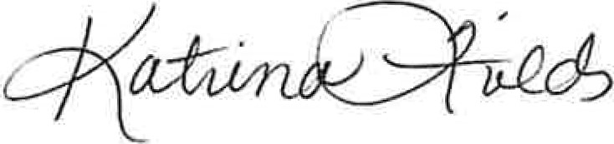
Katrina Fields, Contract Specialist

A FACILITY OF THE MISSISSIPPI DEPARTMENT OF MENTAL HEALTH ACCREDITED BY THE JOINT COMMISSION ON ACCREDITATION OF HEALTHCARE ORGANIZATIONS

MISSISSIPPI STATE HOSPITAL

P.O. BOX 157-A, WHITFIELD, MS 39193 (601) 351-8000 WWW.MSH.STATE.MS.US
Date: 3/30/2022
Janus G. Chastain, FACHE
RFx3150004092
Name:
Dear Mr./Ms
We would like to thank you for participating in the interview process to fill the Mississippi State Hospital's Contract Nurse position. We enjoyed having the opportunity to meet with you and discuss your experiences and qualifications for the position. We were pleased with the caliber of the candidates we interviewed. While the decision was not an easy one, we have made the decision to offer the position to another candidate. Thank you for your interest in this position. We hope that you will continue to consider opportunities at MSH. We wish you the best in your future professional endeavors.
If you would like to protest the selection and/or request a debriefing, please refer to the PPRB OPSCR Rules and Regulations dealing with protests and/or debriefings.
Sincerely,
Katina Fields, Contract Specialist, MS State Hospital

A FACILITY OF THE MISSISSIPPI DEPARTMENT OF MENTAL HEALTH

ACCREDITED BY THE JOINT COMMISSION ON ACCREDITATION OF HEALTHCARE ORGANIZATIONS

